**Ligand-Based Drug Discovery: A Key Approach in Anticancer Drug Development**

Ligand-based drug discovery (LBDD) is an innovative approach that has revolutionized drug design and development, especially in the absence of target structures. This method relies on known chemical structures that modulate specific targets, making it highly valuable when the 3D structure of a target protein is unavailable. In the context of drug discovery, LBDD has become increasingly significant, offering strategic insights that reduce costs and improve productivity (Yang et al., 2021; Das & Agarwal, 2024; Moingeon et al., 2022).

With the invention of Computer-aided drug design (CADD), it saves up to 30% of the time and money of a drug development process and has become an integral part of research and development in pharmaceutical industries (Sharma et al., 2021). Techniques such as quantitative structure-activity relationship (QSAR) modeling and pharmacophore modeling are crucial components of LBDD, enabling researchers to identify and optimize potential drug candidates, particularly in cancer therapy, where the need for selective and effective treatments is pressing. These techniques reveal target-ligand interactions, enabling lead discovery and optimization prediction models.

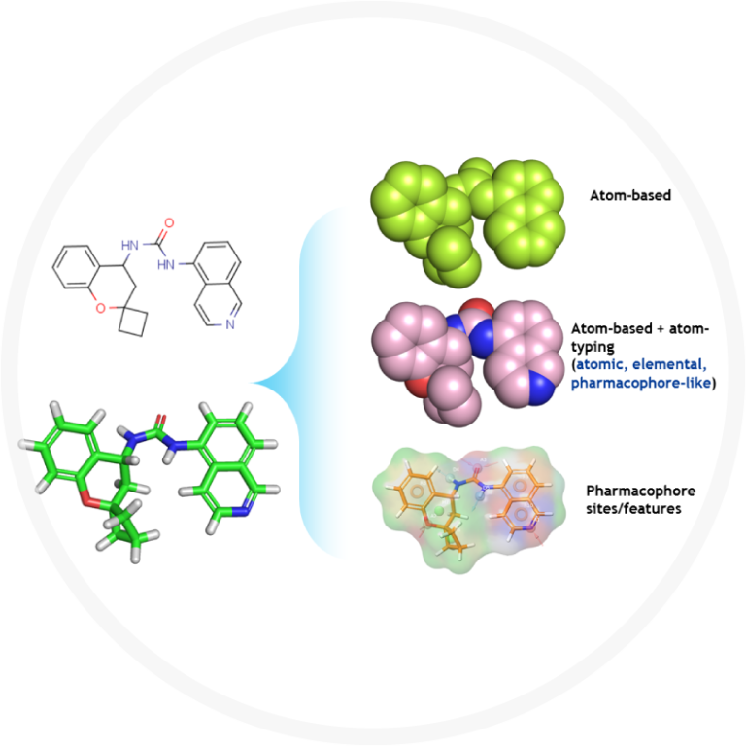

Figure 1: Diagram of ligand-based drug discovery

In the last decade, cancer has been a leading cause of death worldwide. Despite the impressive progress in cancer therapy, firsthand treatments are not selective to cancer cells and cause serious toxicity. Thus, the design and development of selective and innovative small molecule drugs is of great interest hence the computerized approach (del Carmen & Campos, 2023). The highly efficient and specific nanocarrier-mediated ligand-based active therapy is one of the novel and promising approaches for delivery of the therapeutics for different cancers in recent years to restrict various cancer growth in vivo without harming healthy cells (Bandyopadhyay et al., 2023).

One of the recent advancements in ligand-based technique has been used to design tubulin inhibitors that target tubulin polymerization, which is essential for cell cycle progression and cell division (Prada et al., 2019). Furthermore, a human aromatase (HA) inhibitor has been developed, utilizing ligand-based approaches, to treat estrogen receptor-positive (ER+) breast cancer (Spinello et al., 2016).

The success of these ligand-based methods in cancer therapy illustrates the broader potential of computational approaches in drug discovery. As research in this field continues to evolve, there is great optimism that LBDD will play an increasingly central role in the development of novel therapeutics, offering new hope for patients with cancer and other life-threatening diseases.

**References**

Bandyopadhyay, A., Das, T., Nandy, S. et al. Ligand-based active targeting strategies for

cancer theranostics. Naunyn-Schmiedeberg's Arch Pharmacol 396, 3417–3441 (2023). <https://doi.org/10.1007/s00210-023-02612-4>.

Das, A. P., & Agarwal, S. M. (2024). Recent advances in the area of plant-based anti-

cancer drug discovery using computational approaches. Molecular Diversity, 28(2), 901-925.

Del Carmen Quintal Bojórquez, N., & Campos, M. R. (2023). Traditional and Novel

Computer-Aided Drug Design (CADD) Approaches in the Anticancer Drug Discovery Process. Current Cancer Drug Targets, 23(5), 333-345. **DOI:** <https://doi.org/10.2174/1568009622666220705104249>.

Moingeon, P., Kuenemann, M., & Guedj, M. (2022). Artificial intelligence-enhanced drug

design and development: Toward a computational precision medicine. Drug discovery today, 27(1), 215-222.

Prada-Gracia, D., Huerta-Yépez, S., & Moreno-Vargas, L. M. (2016). Application of

computational methods for anticancer drug discovery, design, and optimization. *Boletín Médico Del Hospital Infantil de México (English Edition)*, *73*(6), 411-423.

<https://doi.org/10.1016/j.bmhime.2017.11.040>.

Sharma, V., Wakode, S., & Kumar, H. (2021). Structure-and ligand-based drug design:

Concepts, approaches, and challenges. Chemo informatics and bioinformatics in the pharmaceutical sciences, 27-53. <https://doi.org/10.1016/B978-0-12-821748-1.00004-X>.

Spinello, A., Ritacco, I., & Magistrato, A. (2019). Recent advances in computational

design of potent aromatase inhibitors: open-eye on endocrine-resistant breast cancers. *Expert Opinion on Drug Discovery*, *14*(10), 1065-1076. <https://doi.org/10.1080/17460441.2019.1646245>.

Yang, S. Q., Ye, Q., Ding, J. J., Ming‐Zhu Yin, Lu, A. P., Chen, X., ... & Cao, D. S. (2021).

Current advances in ligand‐based target prediction. Wiley Interdisciplinary Reviews: Computational Molecular Science, 11(3), e1504. [**https://doi.org/10.1002/wcms.1504**](https://doi.org/10.1002/wcms.1504).